NATIONAL FINALS BALLOTING PROCEDURES
A. First Ballot:
At the conclusion of the performance category, each adjudicator shall independently complete and sign their ballot, using the following procedures:
Exactly 3 unranked “yes” votes for the three competitors the adjudicator believes most qualified to receive the top three places.
- Write exactly 3 unranked “yes” votes for the three competitors the adjudicator believes most qualified to receive the top three prizes.
- Write exactly 1 unranked “maybe” vote (to be used for tie-breaking purposes only) for the competitor the adjudicator believes to be next most qualified.
The National Competition Coordinator shall tally and determine the result of the balloting using the below form.
“Yes” votes shall be tallied and the three competitors with the highest number of “yes” votes shall move to the Second Ballot.
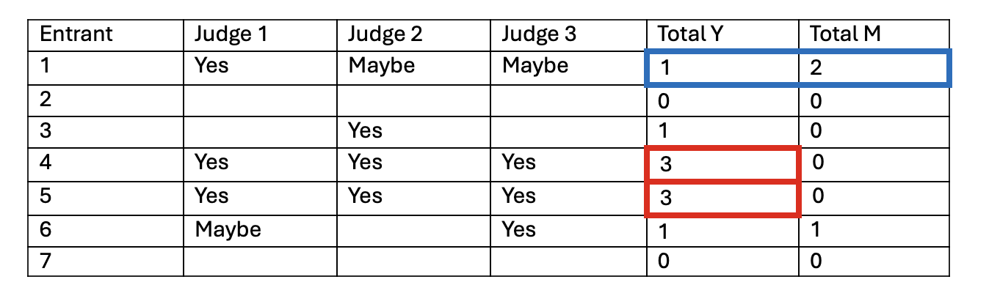
Tie First Ballot:
Should a tie vote make it impossible to determine the top three finalists, the alternate “maybe” votes of those competitors who are tied shall be tallied. The top three finalists shall be chosen based on the number of alternate votes received. In the above example, entrants 1, 4, and 5 would progress to the second ballot.
Should a tie occur in the number of “maybe” votes, the competition coordinator will announce who received “maybe” votes, and the adjudicators will take a second vote among the tied competitors to reduce or eliminate the tie.
Should a tie recur, the adjudicators will ballot again to resolve the tie.

B. Second Ballot:
Using the list of three names determined above, each adjudicator shall independently complete and sign a ballot, ranking the finalists as first, second, or third.
The National Competition Coordinator shall tally and determine the result of the balloting.
The competitor receiving the highest number of first-place votes will receive first prize. The competitor receiving the highest total number of first place and second place votes will receive the second prize, and the remaining competitor will receive third prize.
Tie Second Ballot:
Should a tie occur at any stage of the Second Ballot, the adjudicators will take another vote among the tied competitors to eliminate the tie.
Should a tie recur, the adjudicators will ballot again to resolve the tie.

Revised, July 2026

