2026 MTNA Junior Woodwind
Saturday, March 21, 2026
Chicago Marriott Downtown Magnificent Mile– Lincolnshire I/II

Entrant #1: Claire Choi (Flute) (9:00 a. m.)
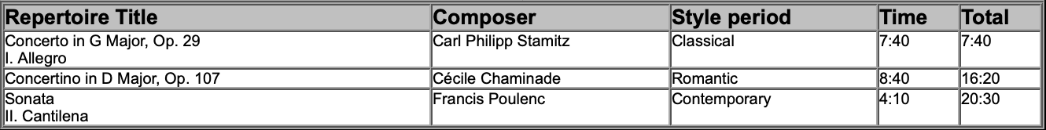

Entrant #2: Aidan Zhao (Saxophone) (9:25 a. m.)
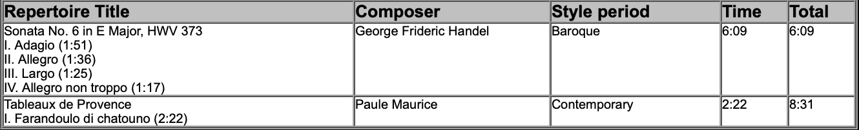

Entrant #3: Annie Liu (Flute) (9:50 a. m.)
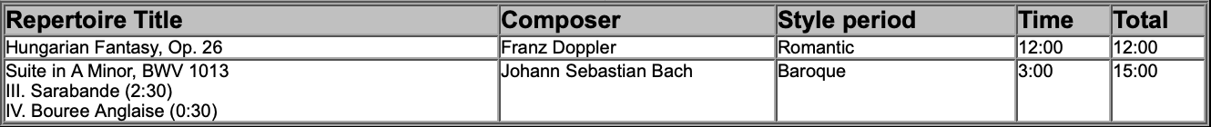

BREAK 10:15-10:30 A.M.

Entrant #4: Elizabeth Hwang (Flute) (10:30 a. m.)
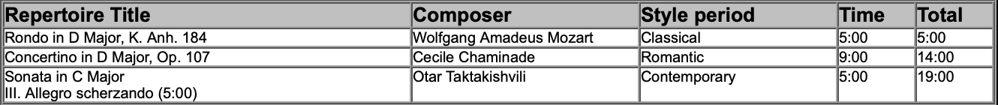
2026 MTNA Junior Woodwind
Saturday, March 21, 2026
Chicago Marriott Downtown Magnificent Mile– Lincolnshire I/II

Entrant #5: Mazon Jeong (Flute) (10:55 a. m.)

Entrant #6: Naryn Kim (Flute) (11:20 a. m.)

Entrant #7: Lucy Kessler (Flute) (11:45 a. m.)
