2026 MTNA Junior Strings
Saturday, March 21, 2026
Chicago Marriott Downtown Magnificent Mile– Great America I/II

Entrant #1: Josie Snaza (Violin) (8:45 a. m.)
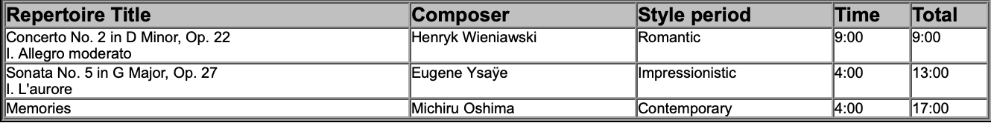

Entrant #2: Daniel Liu (Violin) (9:10 a. m.)
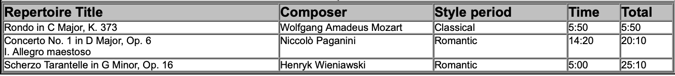

Entrant #3: George Na (Violin) (9:35 a. m.)
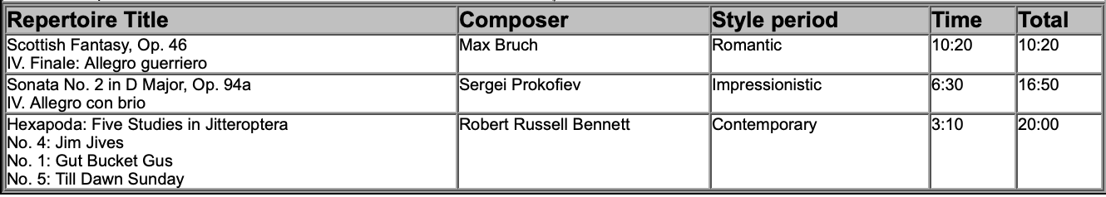

BREAK 10:00-10:15 A.M.

Entrant #4: Anthony Kim (Cello) (10:15 a. m.)
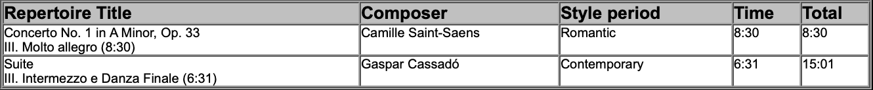
2026 MTNA Junior Strings
Saturday, March 21, 2026
Chicago Marriott Downtown Magnificent Mile– Great America I/II

Entrant #5: Katherine Lu (Cello) (10:40 a. m.)
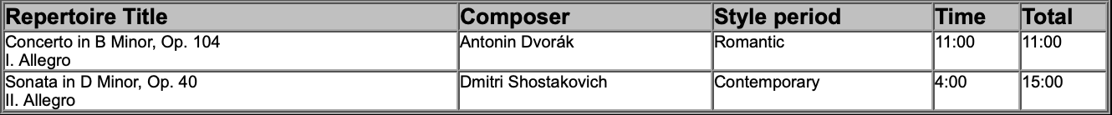

Entrant #6: Yosef Kogan (Violin) (11:05 a. m.)

Entrant #7: Justin Lee (Cello) (11:30 a. m.)
