2026 MTNA Junior Piano
Saturday, March 21, 2026
Chicago Marriott Downtown Magnificent Mile– Chicago Ballroom D

Entrant #1: Biyun Jiao (8:30a. m.)
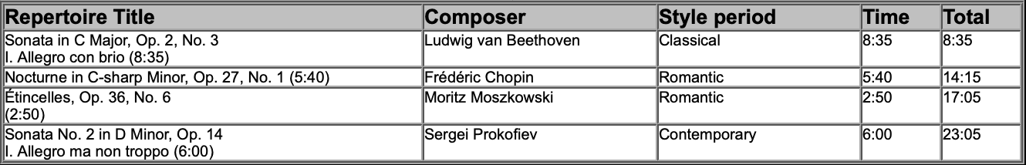

Entrant #2: Zachary Cheng (8:55 a. m.)
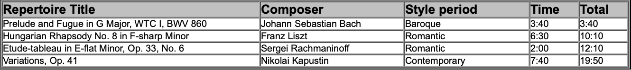

Entrant #3: Sarah Fernandes (9:20 a. m.)

BREAK 9:45-10:00 A.M.
Entrant #4: Ethan Mihaescu (10:00 a. m.)
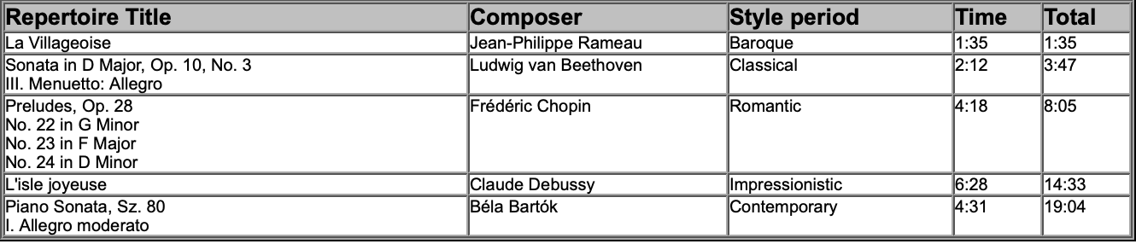

2026 MTNA Junior Piano
Saturday, March 21, 2026
Chicago Marriott Downtown Magnificent Mile– Chicago Ballroom D

Entrant #5: Yuzhe Chen (10:25 a. m.)
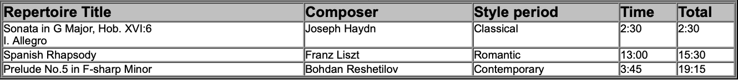
Entrant #6: Bowen Liang (10:50 a. m.)
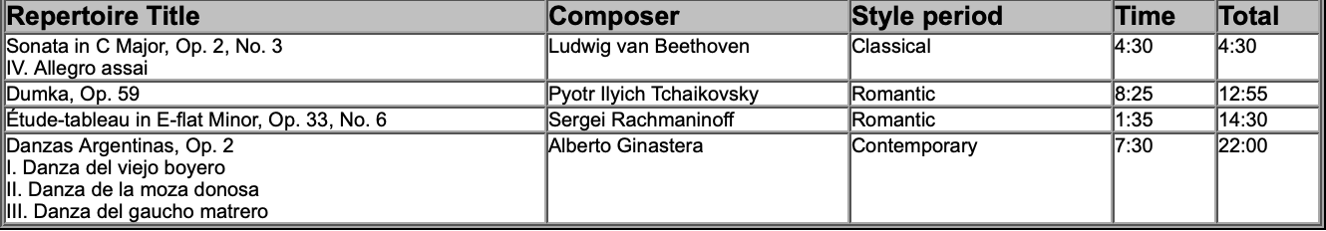
Entrant #7: Isabel Feng (11:15 a. m.)
