2026 MTNA Senior Piano Duet
Sunday, March 22, 2026
Chicago Marriott– Chicago Ballroom C

Entrant #1: Lanie Deng/ Xiaowei Wang (9:15 a.m.)
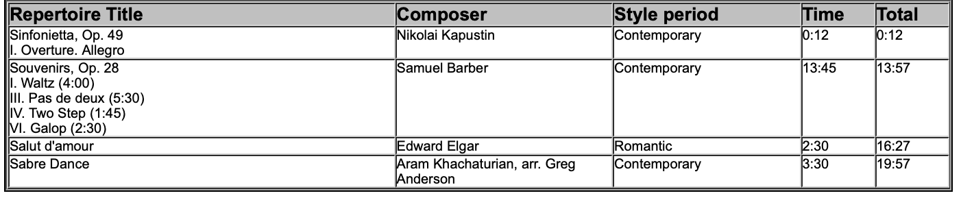
Entrant #2: Olivia Jiang/ Zibo Wang (9:50 a.m.)
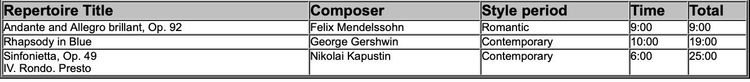

BREAK 10:25-10:40 A.M.

Entrant #3: Kaitlyn Ouyang/ Lucas Pei (10:40 a.m.)

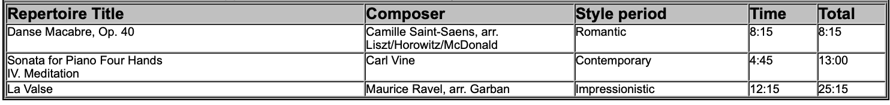

Entrant #4: Albert Hsu/Alexander Rao (11:15 a.m.)

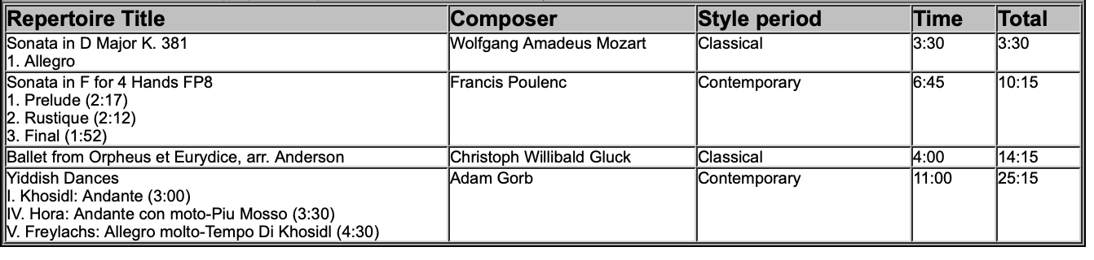

LUNCH 11:50 A.M.-12:50 P.M.

2026 MTNA Senior Piano Duet
Sunday, March 22, 2026
Chicago Marriott– Chicago Ballroom C

Entrant #5: Megan Lai/ Brandon Sang-Zheng (12:50 p.m.)

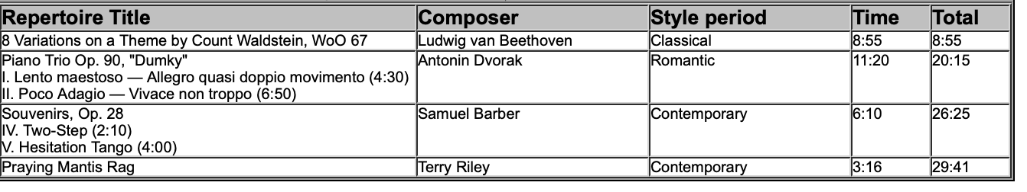

Entrant #6: Rosabelle Shi and Alina Liu (1:25 p.m.)

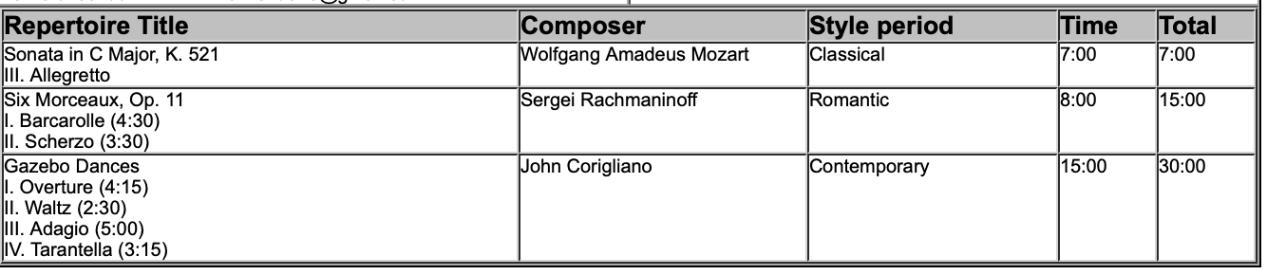

Entrant #7: Conan Yang and Samuel Cronk (2:00 p.m.)

