2026 MTNA Senior Woodwind
Sunday, March 22, 2026
Chicago Marriott– Lincolnshire I/II

Entrant #1: Eric Sigalov (Saxophone) (8:15 a. m.)
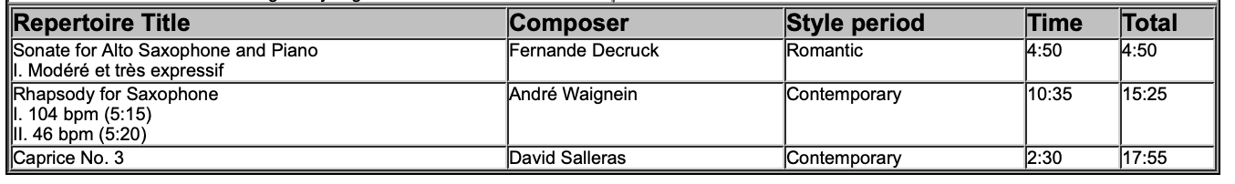
Entrant #2: Silas Gollnick (Saxophone) (8:50 a. m.)

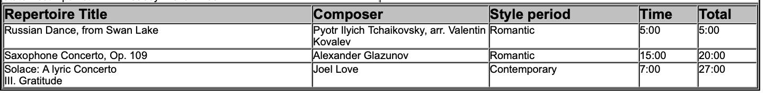

BREAK 9:25-9:40 A.M.

Entrant #3: Soomin Oh (Flute) (9:40 a. m.)

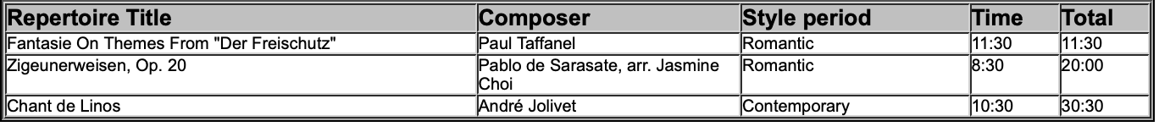

Entrant #4: Annamaria Riccardi (Flute) (10:15 a. m.)

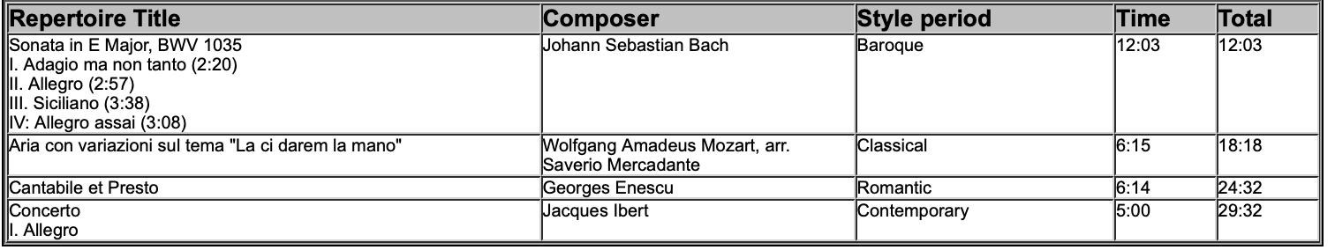

2026 MTNA Senior Woodwind
Sunday, March 22, 2026
Chicago Marriott– Lincolnshire I/II

Entrant #5: Xueheng Wang (Saxophone) (10:50 a. m.)

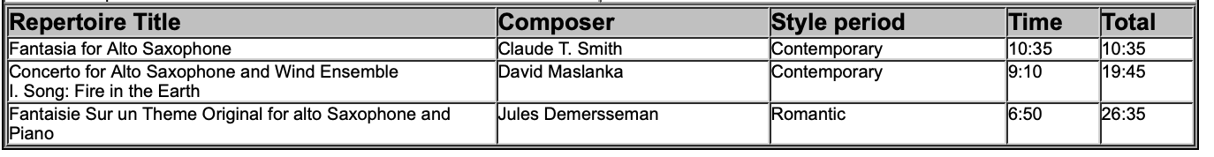

LUNCH 11:30-12:30 P.M.

Entrant #6: Leah Keyes (Flute) (12:30 p. m.)

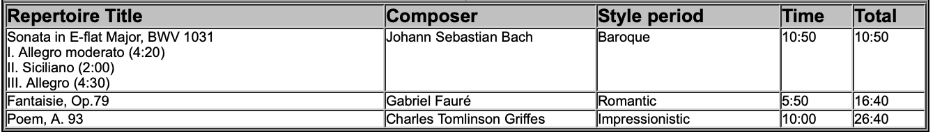

Entrant #7: Owen Burch (Clarinet) (1:05 p. m.)

