2026 MTNA Senior String
Sunday, March 22, 2026
Chicago Marriott– Great America I/II

Entrant #1: Taryn Geiger (Violin) (8:30 a. m.)

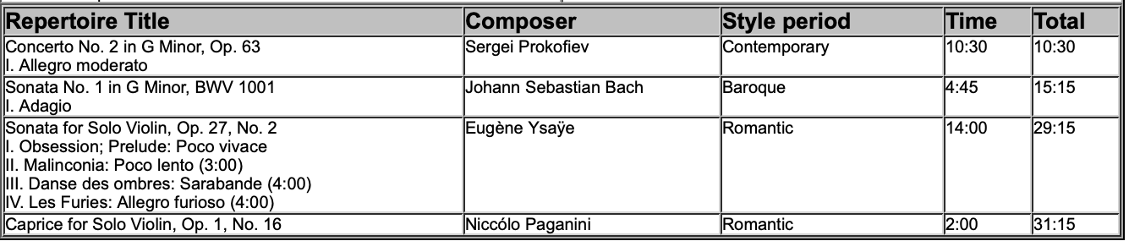
Entrant #2: Emily Chen (Violin) (9:05 a. m.)

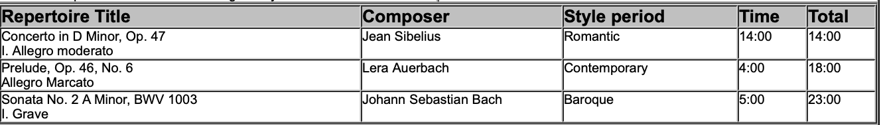

BREAK 9:40 A.M.-9:55 A.M.

Entrant #3: Jesse Krentz (Cello) (9:55 a. m.)

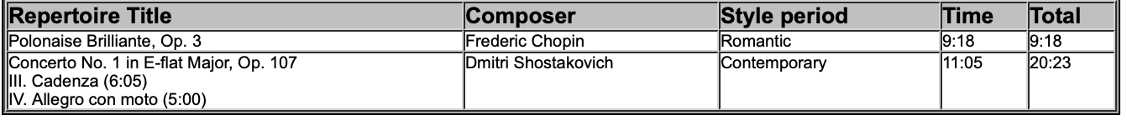

Entrant #4: Kyle Park (Cello) (10:30 a. m.)

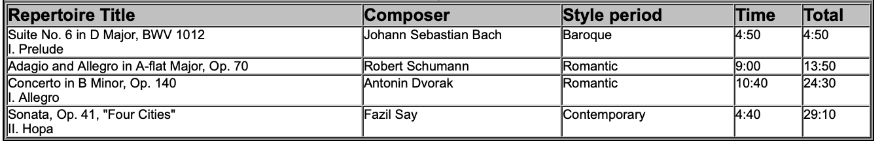

2026 MTNA Senior String
Sunday, March 22, 2026
Chicago Marriott– Great America I/II

Entrant #5: Joshua Lee (Violin) (11:05 a. m.)

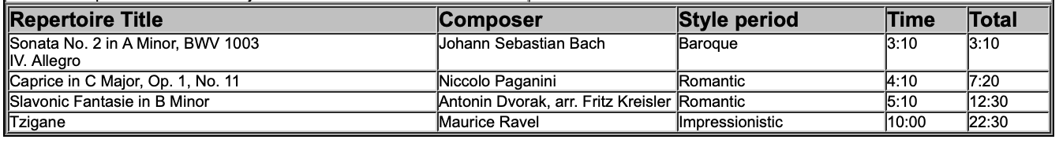

LUNCH 11:40 A.M.-12:40 P.M.

Entrant #6: Leila Warren (Violin) (12:40 p. m.)

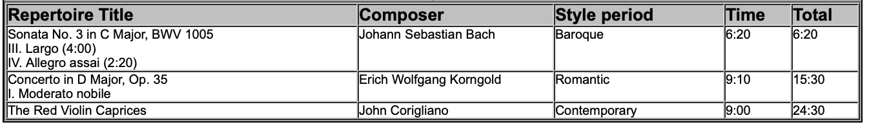

Entrant #7: Yixuan Li (Violin) (1:15 p. m.)

