2026 MTNA Senior Piano
Sunday, March 22, 2026
Chicago Marriott–Chicago Ballroom D

Entrant #1: Evelina Kleczek (8:45 a. m.)
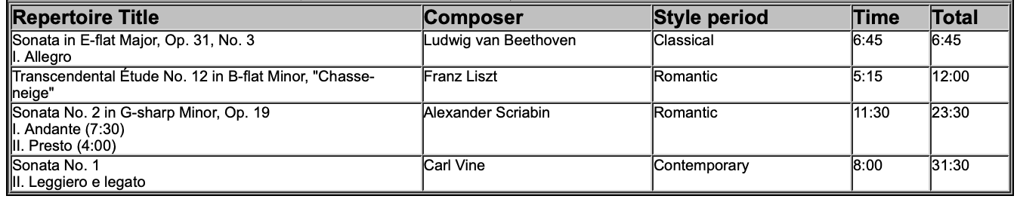
Entrant #2: Evan Dan (9:20 a. m.)

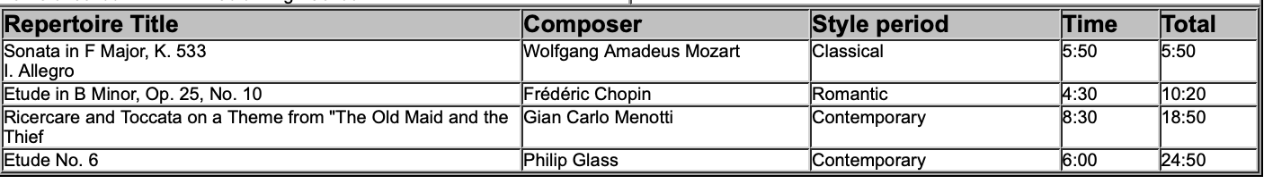

BREAK 9:55-10:10 A.M.

Entrant #3: Enzo Zhao (10:10 a. m.)

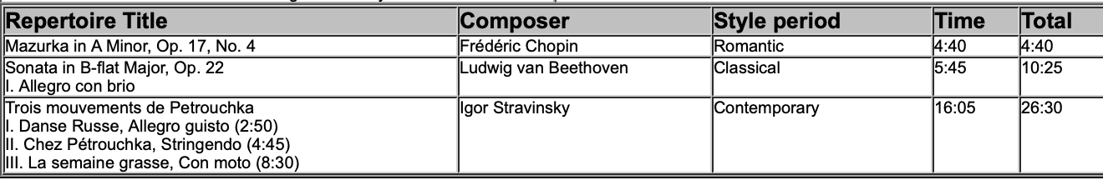

Entrant #4: Chris Hao (10:45 a. m.)

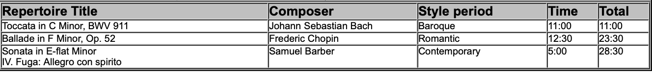

2026 MTNA Senior Piano
Sunday, March 22, 2026
Chicago Marriott–Chicago Ballroom D

Entrant #5: Benjamin Jay Luo (11:20 a. m.)

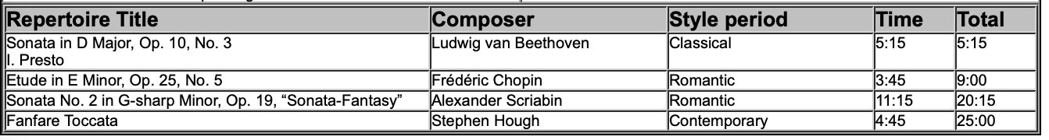

LUNCH 11:55 A.M.-12:55 P.M

Entrant #6: David Gatien (12:55 p. m.)

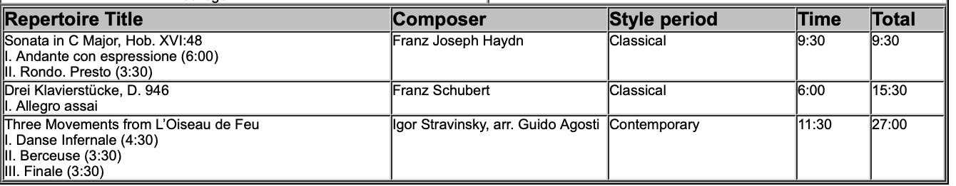

Entrant #7: Noah Greenstein-Sheppard (1:30 p. m.)

