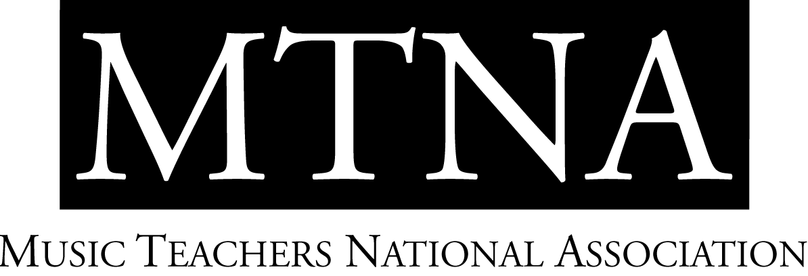

2025-2026 MTNA Junior Performance Competitions

National Finalists and Teachers

The Chicago Marriott Downtown Magnificent Mile
Christina Xie, NCTM, MTNA Young Artist Performance Competitions Coordinator

CATEGORY | ENTRANT | STATE | DIV | TEACHER
YA Brass #1 | Jonah Hammett | GA |  | Jean Martin-Williams
YA Brass #2 | Samuel Cooper | ID |  | Mark Thiele
YA Brass #3 | Diego Jaquez | TX |  | Dave Kirk
YA Brass #4 | Carter Mitchell | WA |  | Chris Dickey
YA Brass #5 | Jon-Michael Taylor | CT |  | Kevin Cobb
YA Brass #6 | Luke Weatherly | OK |  | Paul Compton
YA Brass #7 | Jihong Son | MI |  | David Jackson
YA Piano #1 | Jun Yun | OR | NW | Alexandre Dossin
YA Piano #2 | Tang-Hsing Lien | CO | WC | Stephanie Cheng
YA Piano #3 | Qiaotong Liu | TX | SC | Tamas Ungar
YA Piano #4 | Vitalii Khairutdinov | NJ | E | Veda Zuponcic
YA Piano #5 | Wenzhao Wang | UT | SW | Ning Lu
YA Piano #6 | Quang Vo | FL | S | Michael Baron
YA Piano #7 | Daae Kim | IN | EC | Norman Krieger
YA String #1 | Bethany Bobbs | NJ | E | Catherine Bobbs
YA String #2 | Alina Baron | UT | SW | Leonard Braus
YA String #3 | Vladimir Tsiper | MN | WC | Sergiu Schwartz
YA String #4 | Pavlo Kyryliuk | IL | EC | Almita Vamos
YA String #5 | Daria Oleinik | TX | SC | Alexander Sitkovetsky
YA String #6 | Iris Shepherd | TN | S | Cornelia Heard
YA String #7 | Flora Cummings | WA | NW | Melia Watras

YA Voice #1 | Victoria Hyman | FL | Jeanie Darnell
YA Voice #2 | Cadence Lowery-Hart | IA | Leanne Freeman-Miller
YA Voice #3 | Emilia Jurzyk | IA | Leanne Freeman-Miller
YA Voice #4 | Gabriel McKee | IA | Leanne Freeman-Miller
YA Voice #5 | Leah Mendelin | IA | Leanne Freeman-Miller
YA Voice #6 | Olivia Tice | IA | Leanne Freeman-Miller
YA Voice #7 | Cadie Logston | SD | Tracelyn Gesteland

YA Woodwind #1 | Evan Ney | OR | NW | Idit Shner
YA Woodwind #2 | Hong Cheng | NJ | E | Maureen Hurd Hause
YA Woodwind #3 | Preston Hernandez | LA | SC | Kendra Wheeler
YA Woodwind #4 | Chris Hunley | IA | WC | Kenneth Tse
YA Woodwind #5 | Lillie Gardner | UT | SW | Christina Castellanos
YA Woodwind #6 | Cailin McGarry | FL | S | Jeff Keesecker
YA Woodwind #7 | Matthew Hrinda | IN | EC | Otis Murphy

