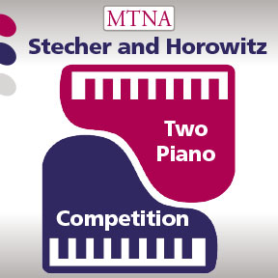

Decision of the Adjudicators

MTNA–Stecher and Horowitz Two Piano Competition National Finals

March 24, 2026, Chicago, Illinois

The competition judges for the Stecher and Horowitz Two Piano competition have made the following decision and by signature certify to this decision:

Winner:

Second Place:

Third Place:

________________________________________

Signature of Judge

________________________________________

Signature of Judge

________________________________________
Signature of Judge

________________________________________

Signature of Competition Coordinator

