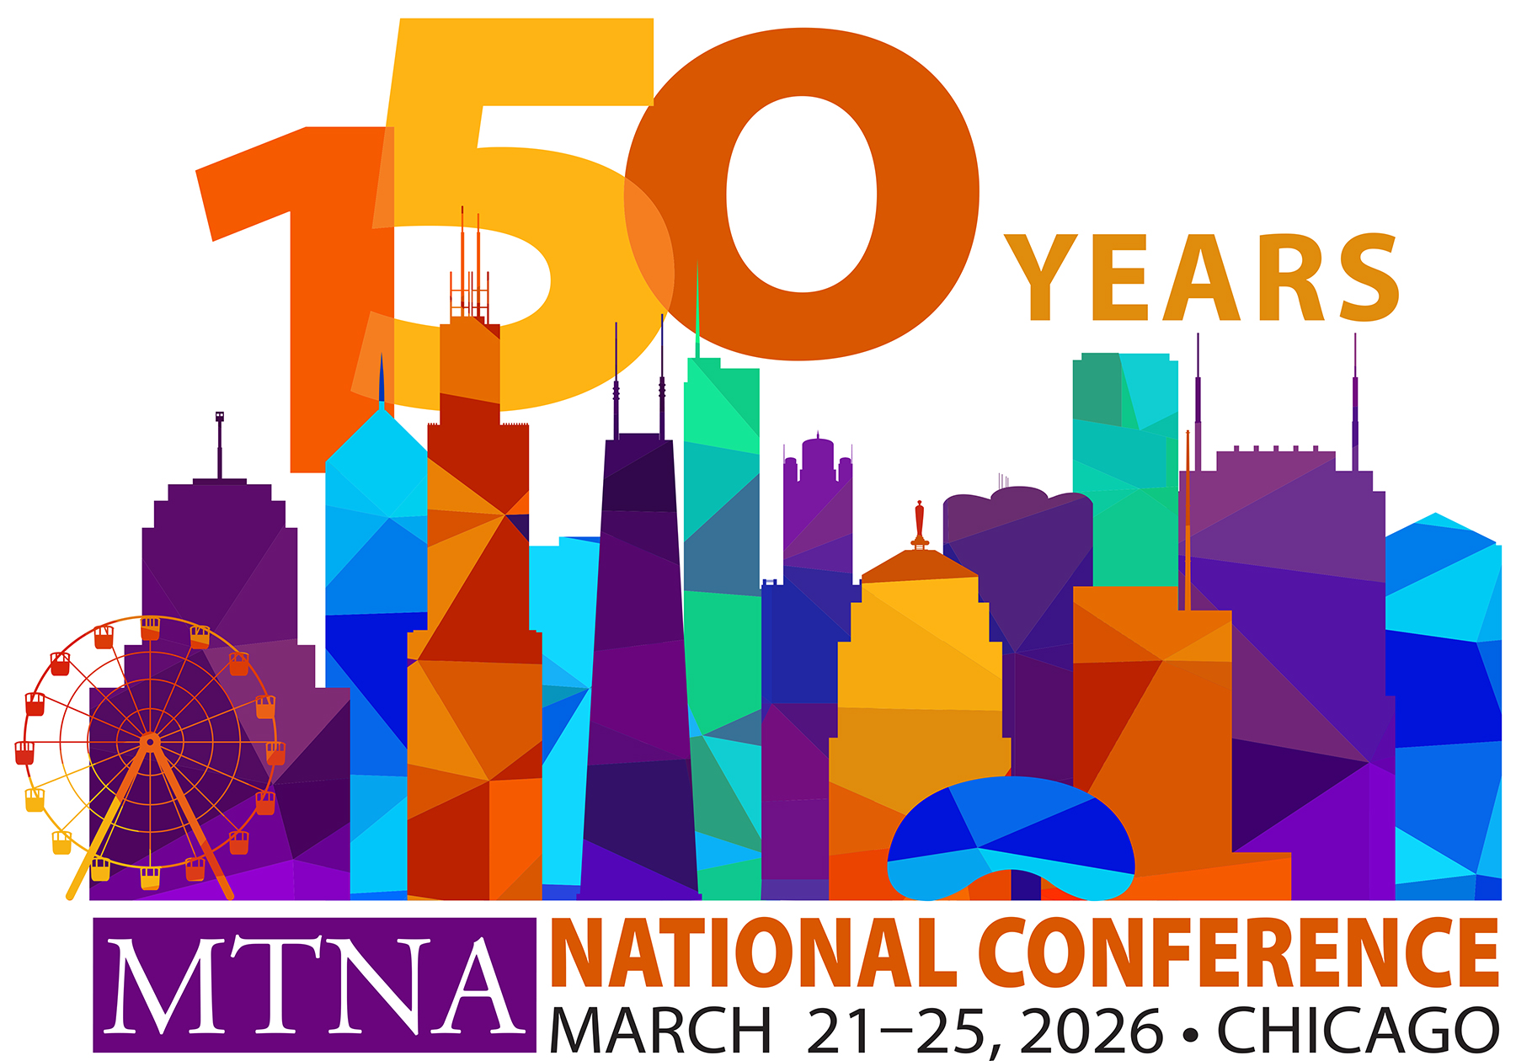
National Finals

Decision of the Adjudicators

MTNA National____________________________________________________
(Category- Brass, Piano, etc.)
Performance Competition ___________________________________________
(Junior Senior, Young Artist, Chamber Music)
The competition judges have made the following decision and by signature certify to this decision:

Winner:

Second Place:

Third Place:

If applicable:

Chopin Award:

Ebony Award:
Oscar Raoul Iotti Award: _______________________________________
________________________________________

Signature of Judge

________________________________________

Signature of Judge

________________________________________
Signature of Judge

________________________________________

Signature of Competition Coordinator

