$15.00 Increase in entry fees for each performance competition.
The non-member entry fee for teachers will be raise from $150.00-$200.00.
For each category, entrants may only enter 10 min. over the max time allowed at the National Final Competition.
The Young Artist Category has been expanded to Ages 19-29.

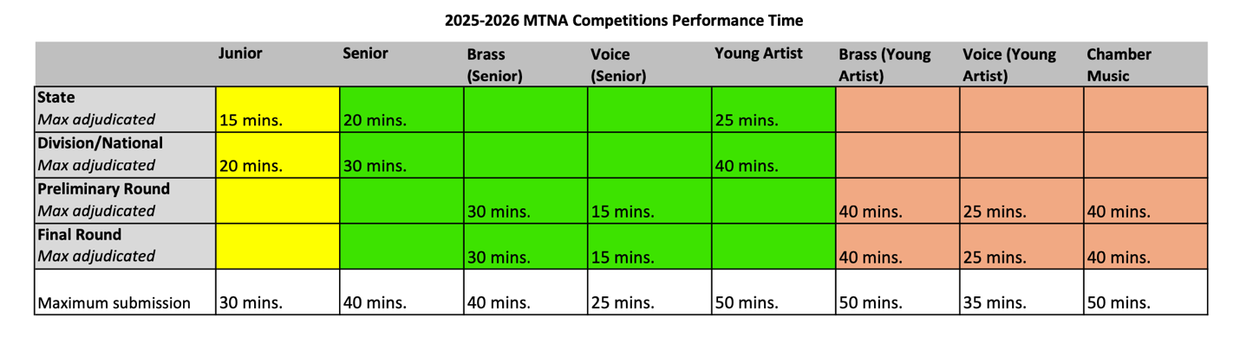
Junior Performance Time:
  - State Competition:
    - Maximum performance time: fifteen (15) minutes
  - Division and National Competitions:
    - Maximum performance time: twenty (20) minutes

Senior Performance time:
  - State Competition:
    - Maximum performance time: twenty (20) minutes
  - Division and National Competitions:
    - Maximum performance time: thirty (30) minutes/ Voice fifteen (15) minutes

Young Artist Performance time:
  - State Competition:
    - Maximum performance time: twenty-five 25) minutes
  - Division and National Competitions:
    - Maximum performance time: forty (40) minutes/ Voice twenty-five (25) minutes

Voice Requirement Changes:

Senior Voice -
•The program must contain only four selections: (include the name of any identifying work from which a song is taken)
-two non-English art songs sung in the original language (must be two different languages)
-one art song sung in English (original language)
-one piece of choice (art song highly encouraged; arias chosen from the operatic or oratorio repertoire may be programmed as appropriate)

Performance time:
- Maximum performance time: fifteen (15) minutes

Young Artist Voice-
The program [a minimum of six (6) selections] must contain repertoire in the original language from each of the following categories: (include the name of any identifying work from which a song or aria is taken).
-Two (2) arias from opera or oratorio repertoire, sung in the original key
-2 art songs (2 contrasting languages)
-1 piece of choice (chosen from art song, opera, or operatic oratorio literature)
-1 piece written in 21st century (art song, opera, or oratorio repertoire only; musical theater selections are not eligible)
Performance time:
- Maximum performance time: twenty-five (25) minutes

MTNA Audio/ Video/Photography Policy
- The MTNA rules state: Audio or video recording and photography of the competitions are strongly discouraged.
1. Must not be sold (individual use only)
2. Must not block another person’s view or stand in the aisles
3. Must not have any flashes, lights, tripods, etc.
4. Must not disrupt the performance or interfere with other peoples’ right to enjoy the performance (unobtrusive seating)
5. Must not record other entrants
6. Video is for family/ studio use, not for social media
- This guideline was put into place as a response to a Supreme Court ruling in favor of the Sony Corporation of America.

