2025 MTNA Senior String

Sunday, March 16, 2025

Hilton Minneapolis- Rochester (3)

Hana Gottesman: **(Violin) (8:30 a. m.)**

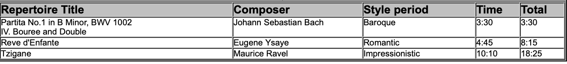  
  
Joshua Lee: **(Violin) (9:05 a. m.)**

**BREAK 9:40 A.M.-9:55 A.M.**

Tristan Zhu: **(Violin) (9:55 a. m.)**

Andrew Lee: **(Viola) (10:30 a. m.)**

2025 MTNA Senior String

Sunday, March 16, 2025

Hilton Minneapolis- Rochester (3)

Brooklynn Thatcher: **(Violin) (11:05 a. m.)**

**LUNCH 11:40 A.M.-12:40 P.M.**

Daniel Qi: **(Violin) (12:40 p. m.)**

Vladimir Tsiper: **(Violin) (1:15 p. m.)**

