MTNA Performance Competition Comment Sheet

Competition: MTNA Senior Piano Duet Finals Date: March 16, 2025

Entrant Name: Kaitlyn Gia Lee /Alexander Vollmer (9:15 a.m.) Instrument or Voice Category: Piano

Judges will be guided in their remarks by the following considerations, as applicable:
Interpretation: style, tempo, dynamic control, phrasing
Technique: rhythmic accuracy, articulation, intonation, tone
Memorization (if applicable) – Stage Presence – Artistic Maturity
If additional pages are used, write the Entrant Name at the top of each page.

Composition Composer Duration
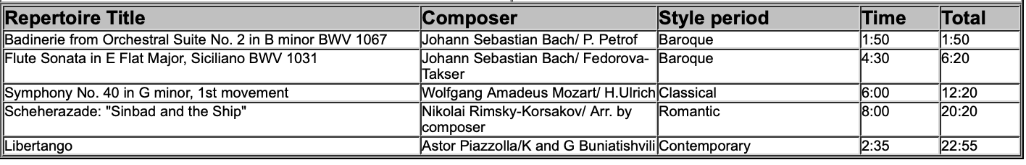

______________________________________________
Signature of Judge

