2025 MTNA Senior Piano Duet

Sunday, March 16, 2025

Hilton Minneapolis - Minneapolis Ballroom Salon E (3)

Kaitlyn Gia Lee /Alexander Vollmer: **(9:15 a.m.)**

Shawn Guo/ Melody Guo: **(9:50 a.m.)**

**BREAK 10:25-10:40 A.M.**

Matvey Moisseyev/ Winston Schneider **(10:40 a.m.)**

2025 MTNA Senior Piano Duet

Sunday, March 16, 2025

Hilton Minneapolis - Minneapolis Ballroom Salon E (3)

Victor Young/Forest Young: **(11:15 a.m.)**

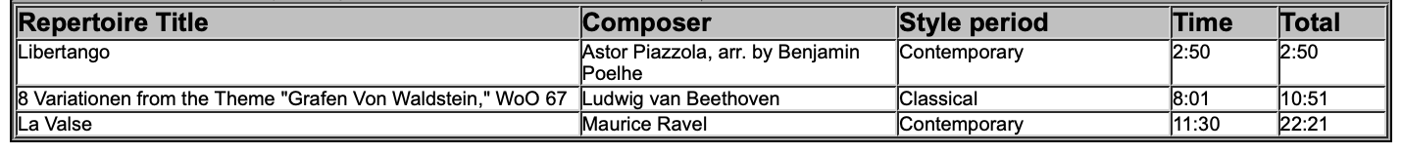

**LUNCH 11:50 A.M.-12:50 P.M.**

Audrey Ren/ Chloe Ren: **(12:50 p.m.)**

Jein Park/ Jeik Park: **(1:25 p.m.)**

Quang Vo/ Lam Nguyen: **(2:00 p.m.)**

