2025 MTNA Senior Woodwind

Sunday, March 16, 2025

Hilton Minneapolis– Duluth (3)

Soomin Oh: **(Flute) (8:15 a. m.)**

Hannah Wolkowitz: **(Saxophone) (8:50 a. m.)**

**BREAK 9:25-9:40 A.M.**

Catherine Cheng: **(Flute) (9:40 a. m.)**

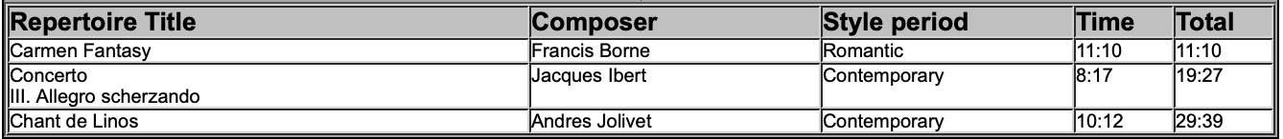

Ethan Hong: **(Saxophone) (10:15 a. m.)**

2025 MTNA Senior Woodwind

Sunday, March 16, 2025

Hilton Minneapolis– Duluth (3)

Diego Chapela-Perez: **(Saxophone) (10:50 a. m.)**

**LUNCH 11:30-12:30 P.M.**

Lina Lin: **(Flute) (12:30 p. m.)**

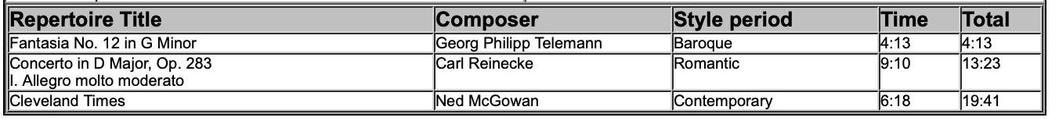

Maia Nemes: **(Flute) (1:05 p. m.)**

