2025 MTNA Senior Piano

Sunday, March 16, 2025  
Hilton Minneapolis - Marquette Ballroom (2)

Quang Vo: **(8:45 a. m.)**

***Composition Composer Duration***

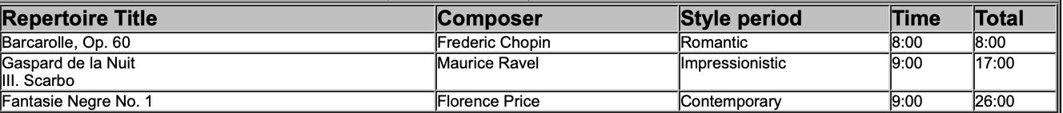

David Choi: **(9:20 a. m.)**

***Composition Composer Duration***

**BREAK 9:55-10:10 A.M.**

Thomas Sinclair: **(10:10 a. m.)**

***Composition Composer Duration***

2025 MTNA Senior Piano

Sunday, March 16, 2025  
Hilton Minneapolis - Marquette Ballroom (2)

Jakob Perlov: **(10:45 a. m.)**

***Composition Composer Duration***

William Wang: **(11:20 a. m.)**

**LUNCH 11:55 A.M.-12:55 P.M**

Matthew Chang: **(12:55 p. m.)**

Keliang Yao: **(1:30 p. m.)**

