2025 MTNA Junior Woodwind

Saturday, March 15, 2025

Hilton Minneapolis– Duluth (3)

Haylee Kulak **(saxophone) (9:00 a. m.)**

Celina Park **(Flute) (9:25 a. m.)**



Grace Li **(Flute) (9:50 a. m.)**

**BREAK 10:15-10:30 A.M.**

Marilyn Ruthruff **(Flute) (10:30 a. m.)**

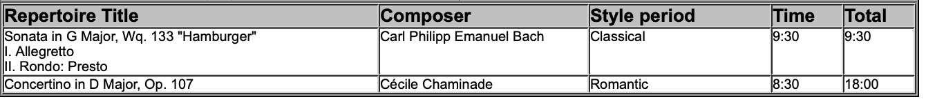

2025 MTNA Junior Woodwind

Saturday, March 15, 2025

Hilton Minneapolis– Duluth (3)

Jianing Liu **(Flute) (10:55 a. m.)**

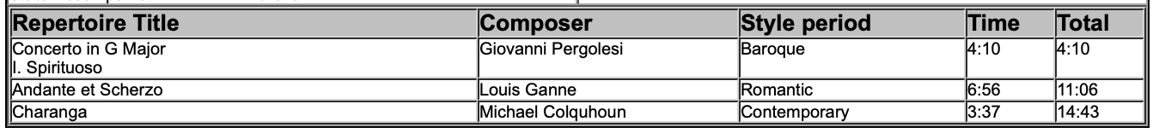

Molly Pickett **(Flute) (11:20 a. m.)**

Ziva Ye **(Saxophone) (11:45 a. m.)**

