2025 MTNA Junior String

Saturday, March 15, 2025

Hilton Minneapolis– Rochester (3)

Charis Shing (**Violin) (8:45 a. m.)**

Daniel Liu **(Violin) (9:10 a. m.)**

Lauren Kang **(Violin) (9:35 a. m.)**

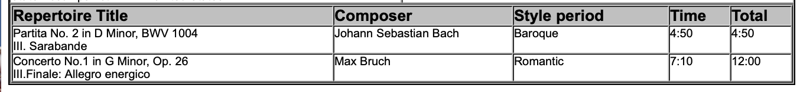

**BREAK 10:00-10:15 A.M.**

Winston Yu (**Cello) (10:15 a. m.)**

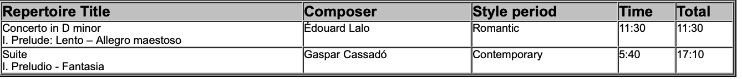

2025 MTNA Junior String

Saturday, March 15, 2025

Hilton Minneapolis– Rochester (3)

Maxwell Brown (**Violin) (10:40 a. m.)**

Elim Wong **(Violin) (11:05 a. m.)**

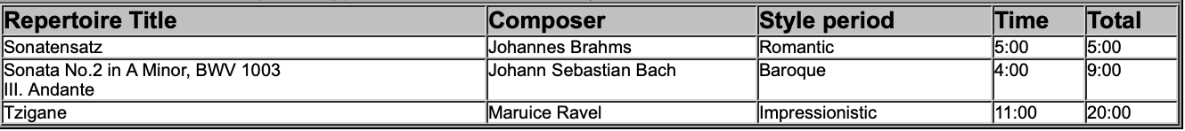

Natalie Xu **(Violin) (11:30 a. m.)  
  
*