2025 MTNA Junior Piano

Saturday, March 15, 2025

Hilton Minneapolis– Marquette Ballroom (2)

Lucas Pei **(8:30a. m.)**

Hudson Dong **(8:55 a. m.)**

Zachary Cheng **(9:20 a. m.)**

**BREAK 9:45-10:00 A.M.**

Christina Sung **(10:00 a. m.)**

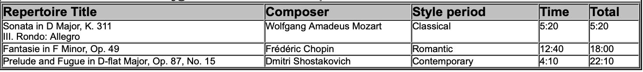

2025 MTNA Junior Piano

Saturday, March 15, 2025

Hilton Minneapolis– Marquette Ballroom (2)

Kaiden Lee **(10:25 a. m.)**

Ella Wan **10:50 a. m.)**

Ethan Mihaescu **11:15 a. m.)**

