2025 MTNA Chamber Music: Wind Category
Saturday, March 15, 2025
Hilton Minneapolis – Conrad D (2)

Ludus Quartet (8:15 a.m.)
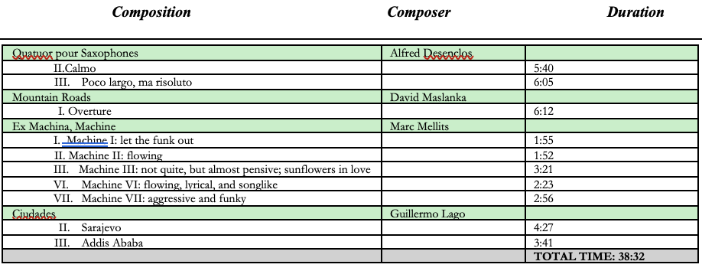

ECHO Quartet (9:00 a.m.)
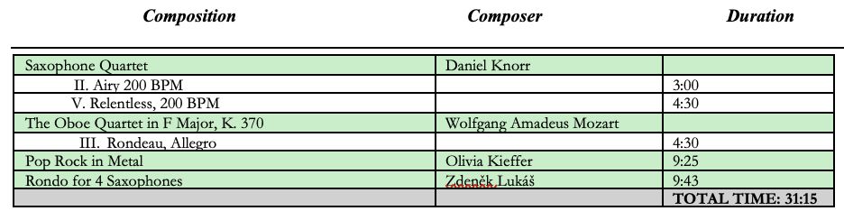

BREAK 9:45 – 10:00 a.m.

Zed (10:00 a.m.)
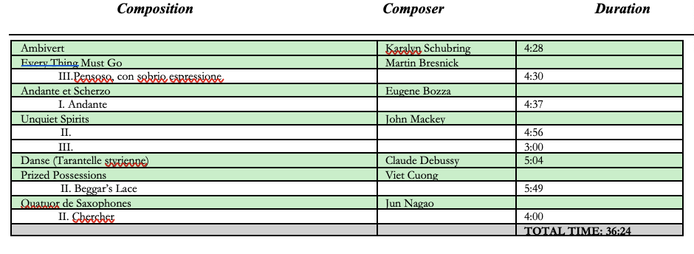

Lighthouse Quartet (10:45 a.m.)
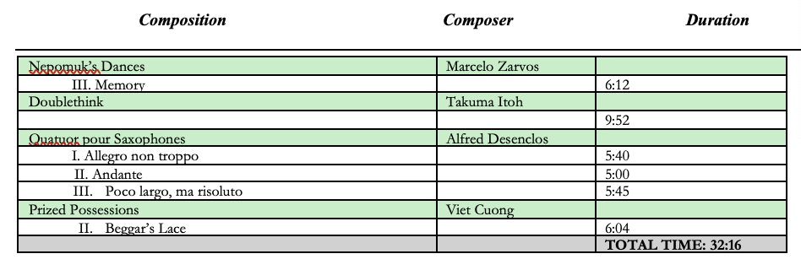

LUNCH 11:30 a.m. – 12:30 p.m.

Center Woodwind Quintet (12:30 p.m.)
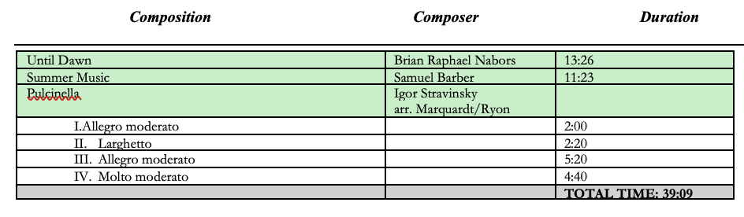

Hierax Quartet (1:15 p.m.)

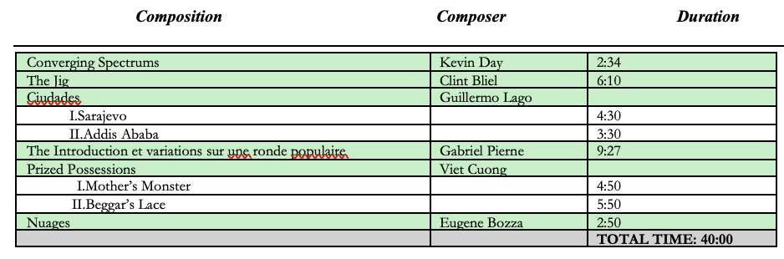

Close Quarters (2:00 p.m.)

