2025 MTNA Chamber Music: String Category
Saturday, March 15, 2025
Hilton Minneapolis – Conrad A (2)

Locus Trio (8:00 a.m.)

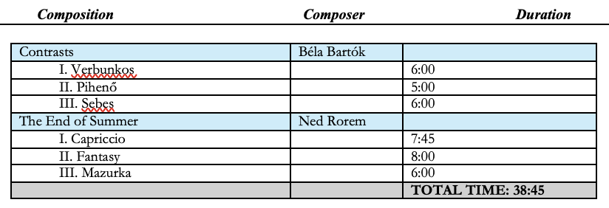

Matcha Trio (8:45 a.m.)
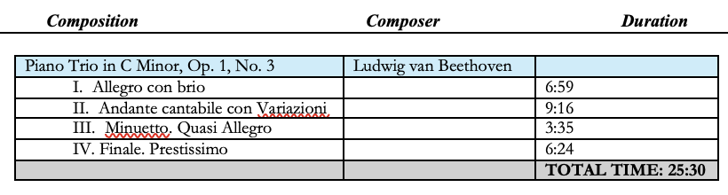

BREAK 9:30 – 9:45 a.m.

Soha Quartet (9:45 a.m.)
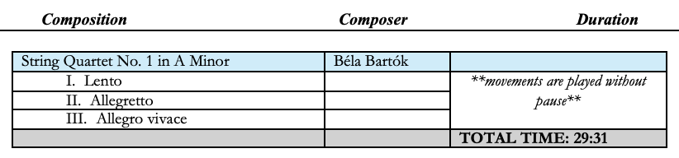

Fabula Trio (10:30 a.m.)
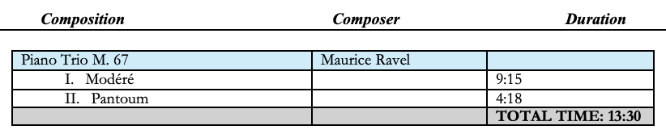

Deluxe Trio (11:15 a.m.)

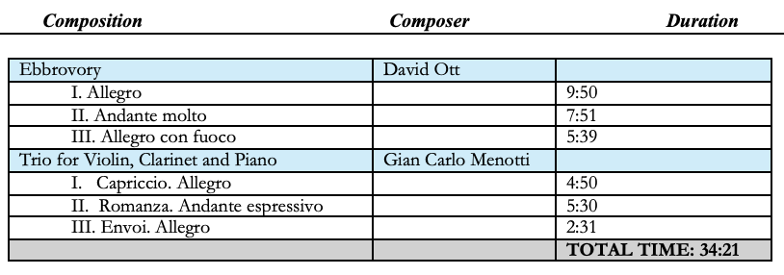

LUNCH 12:00 – 1:00 p.m.

Trio Laval (1:00 p.m.)
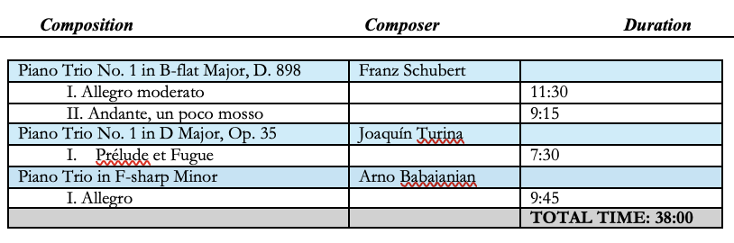

Trio Astra (1:45 p.m.)
