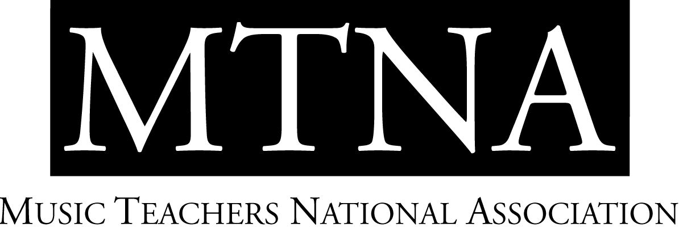

2024-2025 MTNA Young Artist Performance Competitions

National Finalists and Teachers
The Hilton Minneapolis, Minneapolis, MN

Christina Xie, NCTM, MTNA Young Artist Performance Competitions Coordinator

CATEGORY | ENTRANT | STATE | DIV | TEACHER
YA Brass | Eunjeong Lee | CO |  | James Dunn
YA Brass | Ryan Lofland | MI |  | David Zerkel
YA Brass | Bradley Greathouse | NE |  | Alan Mattingly
YA Brass | Geoffrey Sims | AR |  | Brent Shires
YA Brass | Nicholas Dauerer | GA |  | Bradley Palmer
YA Brass | Campbell Byrd | OK |  | Ryan Robinson
YA Brass | Samuel Vance | TN |  | Alexander Lapins
YA Piano | Jacob McKay | ID | NW | Scott Holden
YA Piano | Bonhwi Kim | CA | SW | Yoshikazu Nagai
YA Piano | Elizabeth Low | MI | EC | Christopher Harding
YA Piano | Kevin Cho | TN | S | Heather Conner
YA Piano | Chaihun Kim | MO | WC | Wei-Han Su
YA Piano | Vitalii Khairutdinov | NJ | E | Veda Zuponcic
YA Piano | Ikeobasi Ezike | TX | SC | Bradley Bolen
YA String | Vivienne Lucier | NY | E | Masumi Rostad
YA String | Marina Ziegler | TX | SC | Paul Kantor
YA String | Maxwell Van Hoeij | TN | S | Cornelia Heard
YA String | Alina Baron | UT | SW | Amy Baron
YA String | Joel Lee | WA | NW | John Michel
YA String | Elijah Pouliot | CO | WC | Alex Gonzalez

YA Voice | Abigail Lysinger | TX | Melanie Sonnenberg
YA Voice | Emilia Jurzyk | IA | Leanne Freeman-Miller
YA Voice | Denisse Balandran | SD | Tracelyn Gesteland
YA Voice | Olivia Tice | IA | Leanne Freeman-Miller
YA Voice | Adam Phillips | IA | Leanne Freeman-Miller
YA Voice | Annalisa Blevins | SC | Corinne Parker
YA Voice | Emily Pace | TX | Robert Best

YA Woodwind | Jackson Govern | IL | EC | Nicole Roman
YA Woodwind | Carter Doolittle | NC | S | Robert Young
YA Woodwind | Nicholas Carozza | NV | SW | Stephen Caplan
YA Woodwind | Christopher Hunley | IA | WC | Kenneth Tse
YA Woodwind | Preston Hernandez | LA | SC | Kendra Wheeler
YA Woodwind | Austin Shilling | NY | E | Chien-Kwan Lin

