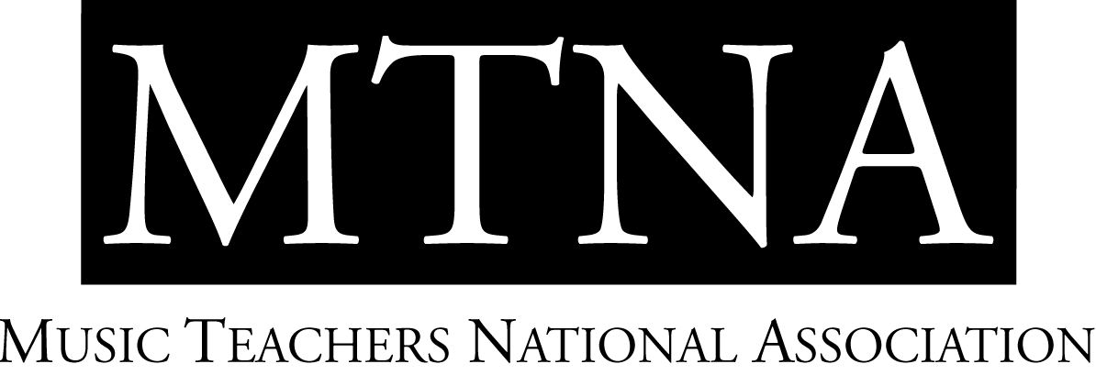

2024-2025 MTNA Chamber Music Performance Competitions

National Finalists and Teachers
The Hilton Minneapolis, Minneapolis, MN

Natalie Landowski NCTM, MTNA Chamber Music Performance Competitions Coordinator

CATEGORY | ENTRANT | School |  | Coach
CM String | Locus Trio | Eastman School of Music |  | Elinor Freer
CM String | Matcha Trio | Eastman School of Music |  | Sylvie Beaudette
CM String | Soha Quartet | University of Texas at Austin |  | Margarita Denenburg
CM String | Fabula Trio | Longy School of Music |  | Wayman Chin
CM String | Deluxe Trio | Eastman School of Music |  | Alan Chow
CM String | Trio Laval | University of Michigan |  | Wayman Chin
CM String | Trio Astra | University of Southern California |  | Jeffrey Kahane
CM Wind | The Ludus Quartet | University of Iowa |  | Kenneth Tse
CM Wind | ECHO Quartet | San Jose State University |  | Michael Hernandez
CM Wind | Zed | University of Texas at Austin |  | Stephen Page
CM Wind | Lighthouse Quartet | University of Oklahoma |  | Myles Boothroyd
CM Wind | Center Woodwind Quintet | University of North Texas |  | Darrel Hale
CM Wind | Hierax Quartet | The Hartt School |  | Darrel Hale
CM Wind | Close Quarters | Florida State University |  | Geoffrey Deibel

600 Vine St., Ste. 1710 • Cincinnati, Ohio 45202
Phone: (513) 421-1420 or (888) 512-5278 • Fax: (513) 421-2503
mtnanet@mtna.org • www.mtna.org

