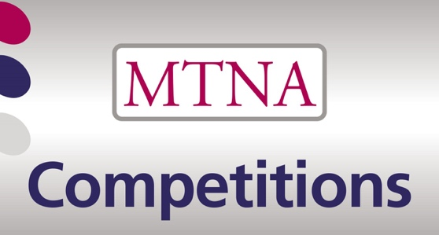

2024 Competitions Committee Agenda
8:00 a.m. March 19, Tuesday
Room 206
Hilton Downtown, Atlanta

NEW BUSINESS

General:
Webpage for our materials
Zoom session for State Chairs
Applications vs Registrations (terms)
Formation of Judging Database
Judges granted the ability to not let a representative proceed to next level
Representatives “required” to perform at State
Adult Competition- Chris Madden email (attached)
Add all Kick back letters in Management System
Email specifically to target membership dues before competitions- especially to colleges
Music brought to competition on ipad
Add a piece vs. switching a piece when invalid
How long to give entrants to answer emails before cancellation- added to rules?
Re-writing of Handbook
Judging with computers
State:
Sound Check Rehearsals
Entrants names publicized or secret?
Link for teachers to verify repertoire? Link to the Do’s and Don’ts Guidelines
Letter to states clarifying MTNA listing of competition positions/ emails received
Update FAQ for State
How do I qualify to enter State?- drop down pick--- resident/ zoom/ out of state etc.
Representatives- “no comments only”
Chamber Music needs to be taken off the State Judges Report

Division:
Accept’d
Bio/ Competition Information for Division- media clarification--- just give us emails
Accompanist sign up confusion/ Pianist confirmation
Form needs a rehaul--- the main links for Junior/ Senior/ YA are not found
YouTube Option?
Pre-recorded accompanists allowed?
Grace period for “late” videos due to uploading speed?
Division Chairs not checking videos are viewable/ judges signing sheets/ ranking 1-2-3
Division Chairs not matching entries and repertoire.
Chad Twedt email (attached)
Calalog #/ publisher/ copyright date/ arranger/ IMSLP / where found
Improvision allowed, especially when not asked for in music
camera no more than 15 feet away/ judges “see” keyboard

Chamber Music:
Need timing on solo pieces

Composition:
Extended Techniques
Digital keyboard with more than on sound to record compositions

National:
Entrant #’s in Program
Online Check in Registration Form

OLD BUSINESS
General:
Need for repertoire standard

UPCOMING DATES

2024-2025 COMPETITION DEADLINES

1. Entry deadline: Wednesday, September 11, 2024, 3:00 p.m. Eastern Time

2. Live state competitions, if possible.

3. STATE COMPETITION DEADLINE: November 10, 2024 (must have all state results by November 12, 2024) [special permission must be obtained from Director of Competitions to hold state competitions later]

4. Division and Chamber Music Competitions video deadline: Wednesday, December 4, 2024, 3:00 p.m. Eastern Time. Registration available November 1, 2024, on the Acceptd site.

5. State Alternate deadline for division videos: Friday, December 13, 2024, 3:00 p.m. Eastern Time.

6. Division and Chamber Music Judging: December 16, 2024-January 6, 2025

7. Stecher and Horowitz deadlines: registration available September 3, 2024; entry deadline on Acceptd January 6, 2025, 3:00 p.m. Eastern Time.

MEETING ADJOURNED

