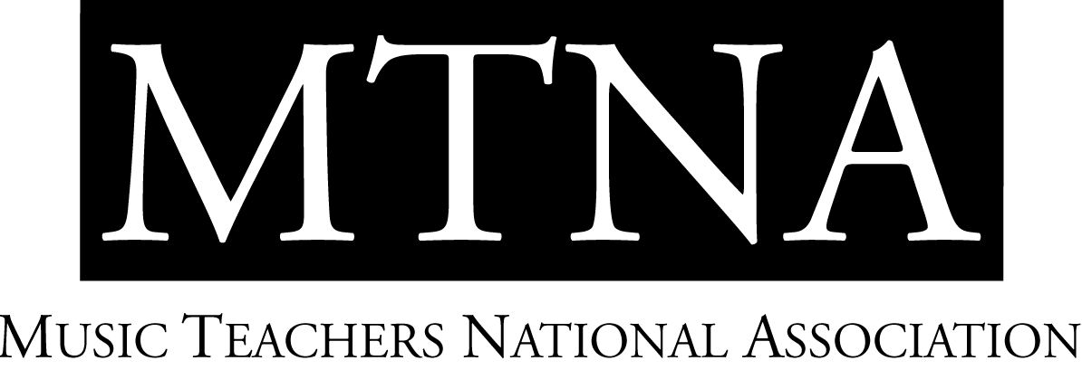

2023-2024 MTNA Young Artist Performance Competitions

National Finalists and Teachers
The Hilton Atlanta, Atlanta, GA

Wei-Yuh Christina Xie, NCTM, MTNA Young Artist Performance Competitions Coordinator

CATEGORY | ENTRANT | STATE | DIV | TEACHER
YA Brass #1 | Natalie Colegrove (Euphonium) | FL | S | Aaron Tindall
YA Brass #2 | Jacob Kittleson (Tuba) | AZ | SW | Deanna Swoboda
YA Brass #3 | Samuel Hardy (Euphonium) | MI | EC | Kenneth Kroesche
YA Brass #4 | Christopher Kemp (Trombone) | MO | WC | Jason Hausback
YA Brass #5 | Campbell Byrd (Euphonium) | OK | SC | Ryan Robinson
YA Brass #6 | Connor Schwarz (Horn) | WA | NW | Jeffrey Snedeker
YA Piano #1 | Ke Tang | NY | E | Joseph Rackers
YA Piano #2 | Sean Yang | TN | S | Logan Skelton
YA Piano #3 | Angeline Ma | IL | EC | James Giles
YA Piano #4 | Qishan Shi | OK | SC | Jeongwon Ham
YA Piano #5 | Jude Dow-Hygelund | CO | WC | Andrew Cooperstock
YA Piano #6 | Jacob Warnick | UT | SW | Jihea Hong-Park
YA Piano #7 | Christopher Richardson | WA | NW | Miri Yampolsky
YA String #1 | Karina Carley (Violin) | SD | WC | Katie Smirnova
YA String #2 | Felix Kim (Cello) | NY | E | Steven Doane
YA String #3 | Camille McLean (Violin) | MI | EC | David Halen
YA String #4 | Dennis Fleitz (Cello) | FL | S | David Bjella
YA String #5 | Nathan Cox (Cello) | UT | SW | Michelle Kesler
YA String #6 | Joel Lee (Cello) | WA | NW | John Michel
YA String #7 | Marco Santistevan (Viola) | TX | SC | Ronald Houston
YA Voice #1 | Molly Snodgrass (Soprano) | NY | E | Amy Burton
YA Voice #2 | Daniela Pepe (Mezzo-Soprano) | FL | S | Jeanie Darnell
YA Voice #3 | Eleni Anthan (Mezzo-Soprano) | IA | WC | Leanne Freeman-Miller
YA Voice #4 | Helena Losada Seabra Salles (Soprano) | TX | SC | Melanie Sonnenberg
YA Voice #5 | Emma Dorsch (Soprano) | WA | NW | Joy Dorsch

YA Woodwind #1 | Darian Angel (Clarinet) | VA | S | Garrick Zoeter
YA Woodwind #2 | Kiana Kawahara (Flute) | TX | SC | Mary Karen Clardy
YA Woodwind #3 | Jeongwon Bae (Flute) | CA | SW | Catherine Karoly
YA Woodwind #4 | Anthony Kandilaroff (Flute) | WA | NW | Sophia Tegart
YA Woodwind #5 | Uday Singh (Saxophone) | NY | E | Chien-Kwan Lin
YA Woodwind #6 | Zachary Costello (Saxophone) | MI | EC | Joseph Lulloff
YA Woodwind #7 | Eric Bergeman (Flute) | ND | WC | Bonita Boyd

