2024 MTNA Senior Woodwind

Sunday, March 17, 2024

Hilton Atlanta Downtown – Room 301

Entrant #1: **(Clarinet) (8:15 a. m.)**

Entrant #2: **(Flute) (8:50 a. m.)**

**BREAK 9:25-9:40 A.M.**

Entrant #3: **(Saxophone) (9:40 a. m.)**

Entrant #4: **(Oboe) (10:15 a. m.)**

2024 MTNA Senior Woodwind

Sunday, March 17, 2024

Hilton Atlanta Downtown – Room 301

Entrant #5: **(Saxophone) (10:50 a. m.)**

**LUNCH 11:30-12:30 P.M.**

Entrant #6: **(Flute) (12:30 p. m.)**

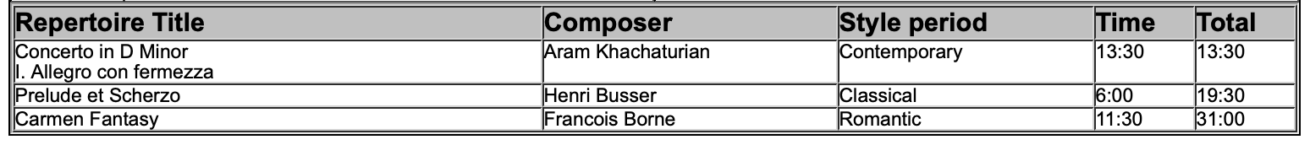

Entrant #7: **(Flute) (1:05 p. m.)**

