2024 MTNA Senior String

Sunday, March 17, 2024

Hilton Atlanta Downtown – Room 303

Entrant #1: **(Violin) (8:30 a. m.)**

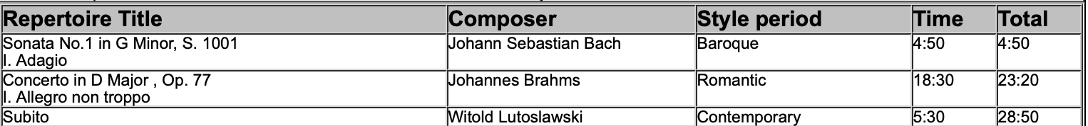  
  
Entrant #2: **(Violin) (9:05 a. m.)**

**BREAK 9:40 A.M.-9:55 A.M.**

Entrant #3: **(9:55 a. m.)**

Entrant #4: **(Violin) (10:30 a. m.)**

2024 MTNA Senior String

Sunday, March 17, 2024

Hilton Atlanta Downtown – Room 303

Entrant #5: **(Violin) (11:05 a. m.)**

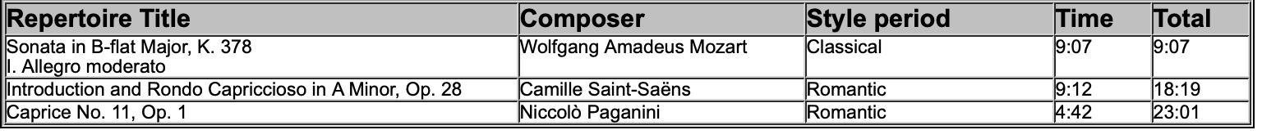

**LUNCH 11:40 A.M.-12:40 P.M.**

Entrant #6: **(Violin) (12:40 p. m.)**

Entrant #7: **(Cello) (1:15 p. m.)**

