2024 MTNA Senior Piano Duet

Sunday, March 17, 2024

Hilton Atlanta Downtown – Crystal Ballroom AF

Entrant #1: **(9:15 a.m.)**  
  


Entrant #2: **(9:50 a.m.)**

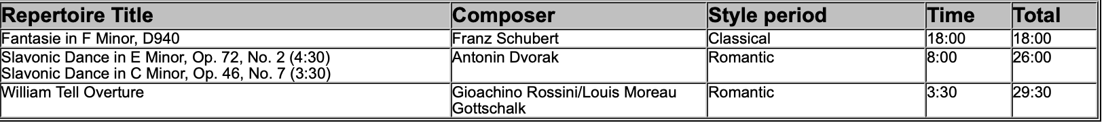

**BREAK 10:25-10:40 A.M.**

Entrant #3: **(10:40 a.m.)**

Entrant #4: **(11:15 a.m.)**

**LUNCH 11:50 A.M.-12:50 P.M.**

2024 MTNA Senior Piano Duet

Sunday, March 17, 2024

Hilton Atlanta Downtown – Crystal Ballroom AF

Entrant #5: **(12:50 p.m.)**

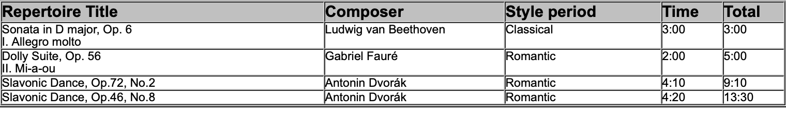

Entrant #6: **(1:25 p.m.)**

Entrant #7: **(2:00 p.m.)**

