2024 MTNA Senior Piano
Sunday, March 17, 2024
Hilton Atlanta Downtown – Grand Ballroom AB

Entrant #1: (8:45 a. m.)
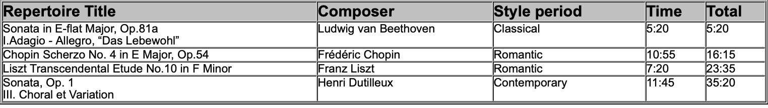
Entrant #2: (9:20 a. m.)

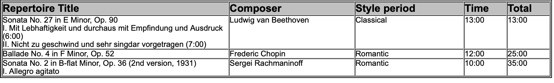

BREAK 9:55-10:10 A.M.

Entrant #3: (10:10 a. m.)

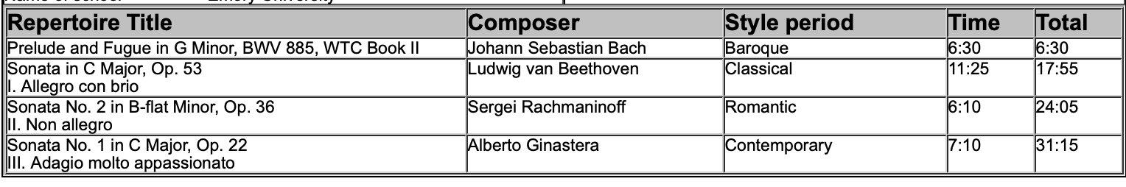

Entrant #4: (10:45 a. m.)

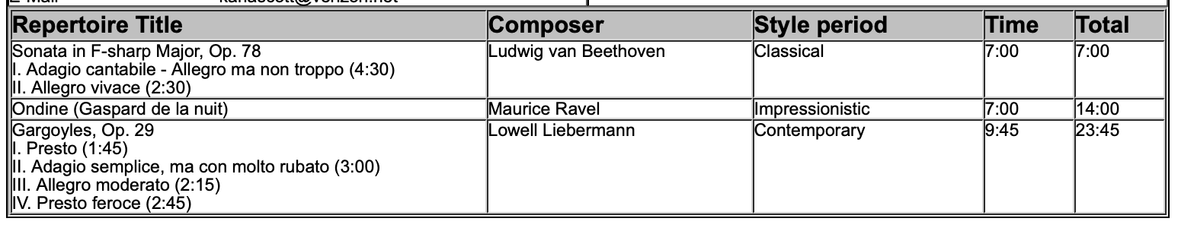
2024 MTNA Senior Piano
Sunday, March 17, 2024
Hilton Atlanta Downtown – Grand Ballroom AB

Entrant #5: (11:20 a. m.)

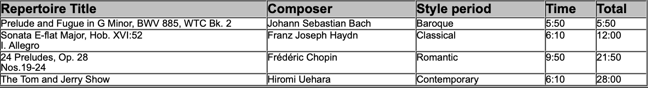

LUNCH 11:55 A.M.-12:55 P.M

Entrant #6: (12:55 p. m.)

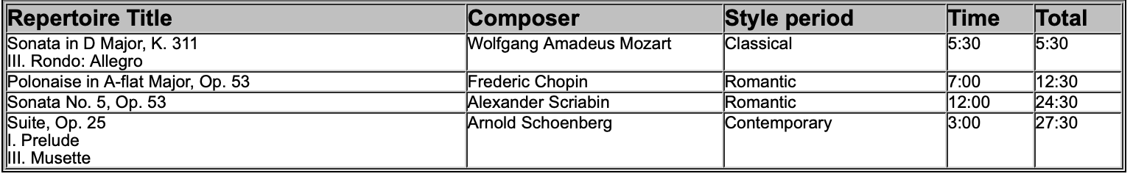

Entrant #7: (1:30 p. m.)

