2024 MTNA Junior Piano

Saturday, March 16, 2024

Hilton Atlanta Downtown – Grand Ballroom AB

Entrant #1: **(8:30a. m.)**

Entrant #2: **(8:55 a. m.)**

Entrant #3: **(9:20 a. m.)**

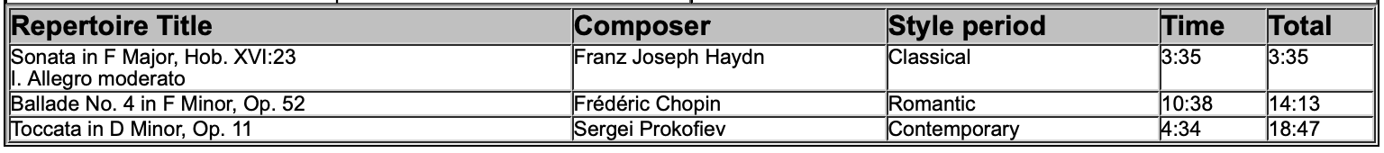

**BREAK 9:45-10:00 A.M.**

Entrant #4: **(10:00 a. m.)**

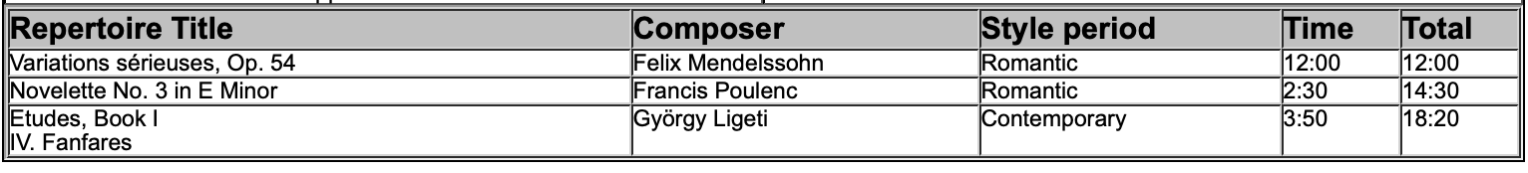

2024 MTNA Junior Piano

Saturday, March 16, 2024

Hilton Atlanta Downtown – Grand Ballroom AB

Entrant #5: **(10:25 a. m.)**

Entrant #6: **(10:50 a. m.)**

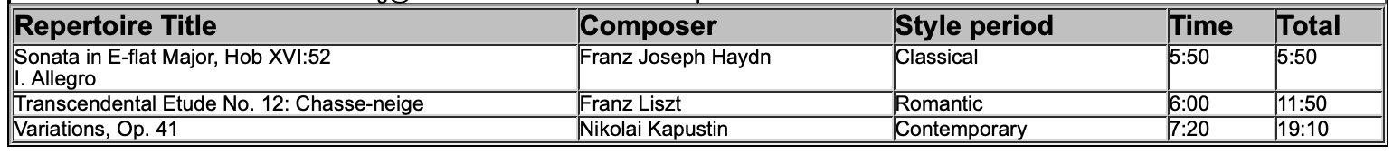

Entrant #7: **(11:15 a. m.)**

